AWS CodeDeploy using S3

Point 1 We need 3 different service roles

- One for Code pipeline -- it will be auto created
- One for Code deploy
- One for EC2 instance
Point 2 We need to install code deploy agent in the EC2 instance where we want to deploy code.

Rules for bucket naming
The following rules apply for naming S3 buckets:

- Bucket names must be between 3 and 63 characters long.
- Bucket names can consist only of lowercase letters, numbers, dots (.), and hyphens (-).
- Bucket names must begin and end with a letter or number.
- Bucket names must not be formatted as an IP address (for example, 192.168.5.4).
- Bucket names can't begin with xn-- (for buckets created after February 2020).
- Bucket names must be unique within a partition. A partition is a grouping of Regions. AWS currently has three partitions: aws (Standard Regions), aws-cn (China Regions), and aws-us-gov (AWS GovCloud [US] Regions).
- Buckets used with Amazon S3 Transfer Acceleration can't have dots (.) in their names. For more information about transfer acceleration, see Amazon S3 Transfer Acceleration.

Step 1 Create a S3 Bucket

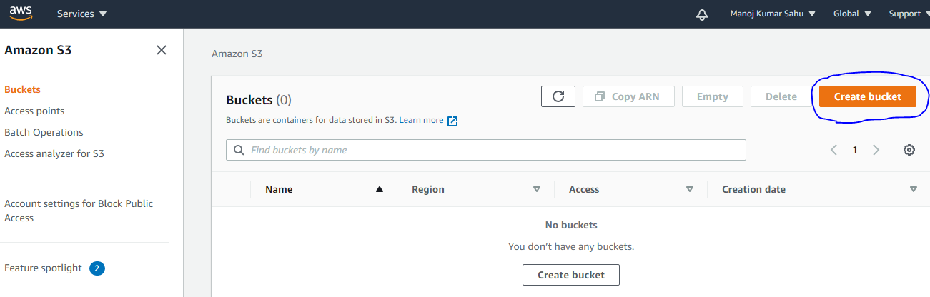

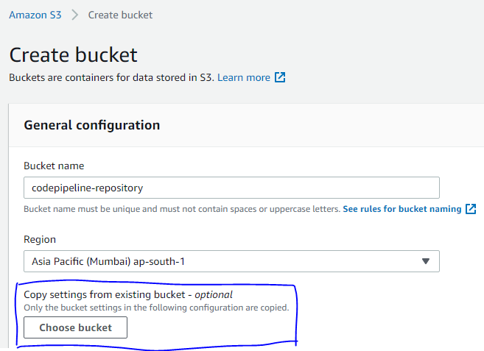
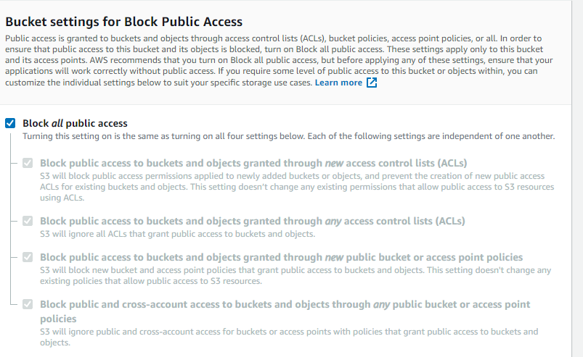

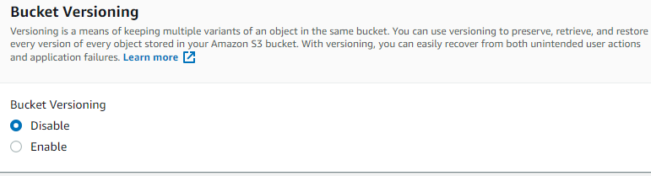
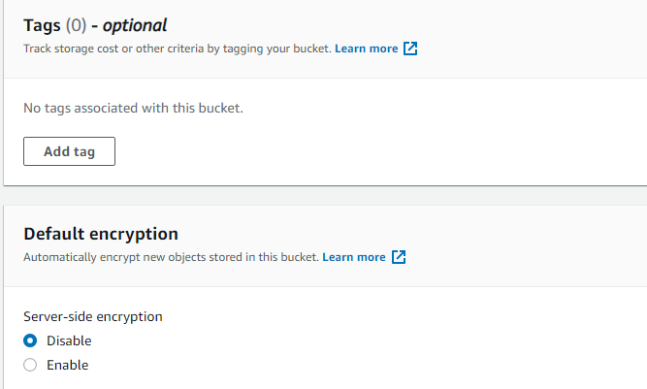
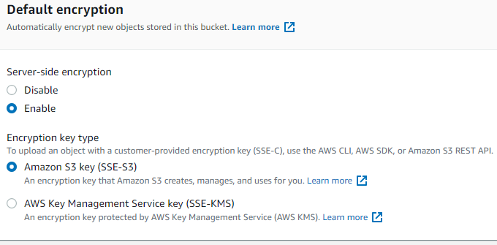

Step 2 Download the sample app zip file -- https://docs.aws.amazon.com/codepipeline/latest/userguide/tutorials-simple-s3.html

Upload the zip file to S3 bucket

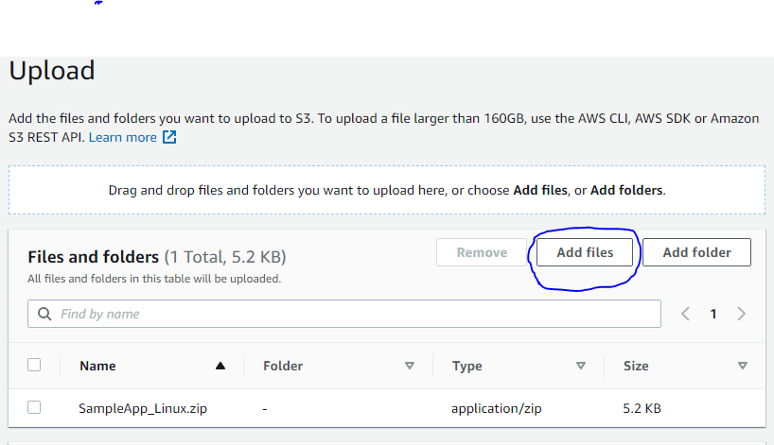

Step 3 Create IAM roles

Go to -> IAM service -> Click roles -> Create role -> select EC2

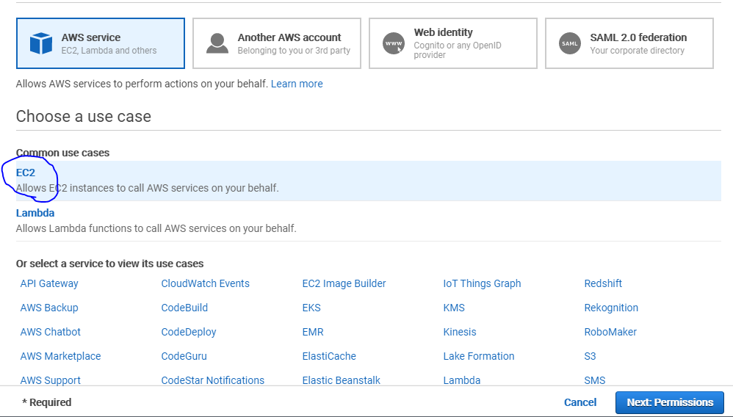

Next click on permission -> search codedeploy -> select as below

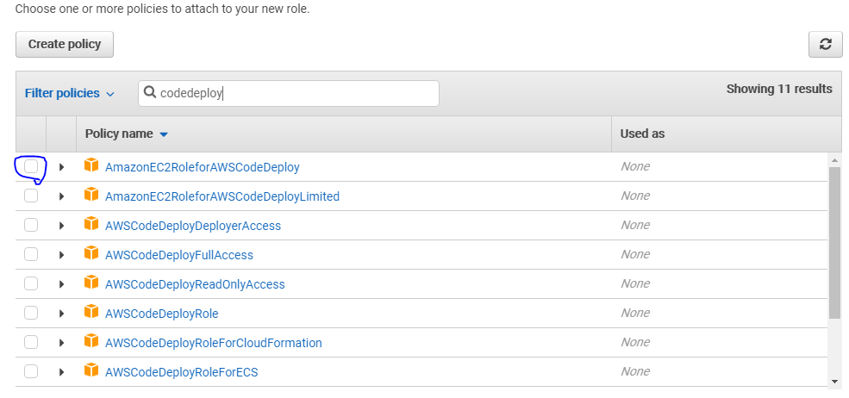

Next click on Add Tags -> It’s optional

Give role name and create role

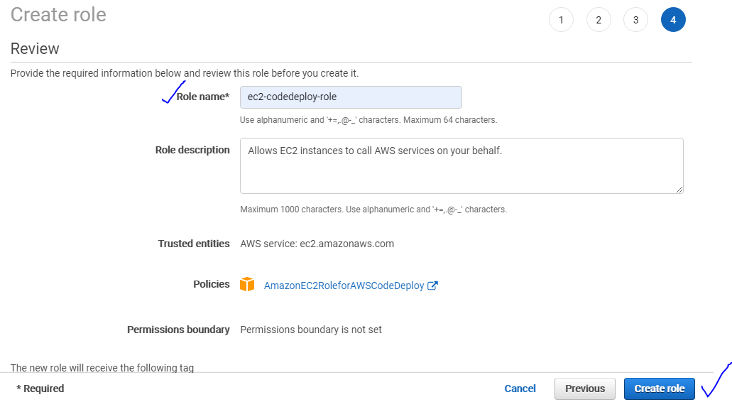

Step 4 Create an EC2 instance and attach the above created role so that it has all the codedeploy capabilities

Go to EC2 service -> Create an EC2 instance and select the IAM role created

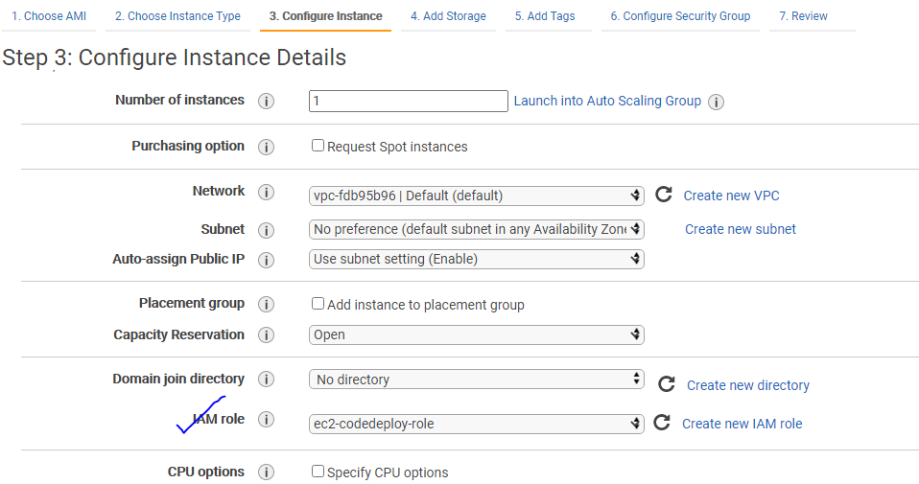
Go to Advanced Details section and paste the below script to install code deploy agent in the EC2 instance while launching. It will take care of the install or uninstall the application.

#!/bin/bash
sudo yum update
sudo yum install -y ruby
sudo yum install wget
sudo yum install -y aws-cli
cd /home/ec2-user
wget https://aws-codedeploy-ap-south-1.s3.ap-south-1.amazonaws.com/latest/install
chmod +x ./install
sudo ./install auto

Bucket name and region identifier should be replaced as per the region in the above script

wget https://bucket-name.s3.region-identifier.amazonaws.com/latest/install

https://docs.aws.amazon.com/codedeploy/latest/userguide/resource-kit.html#resource-kit-bucket-names

Add Tag

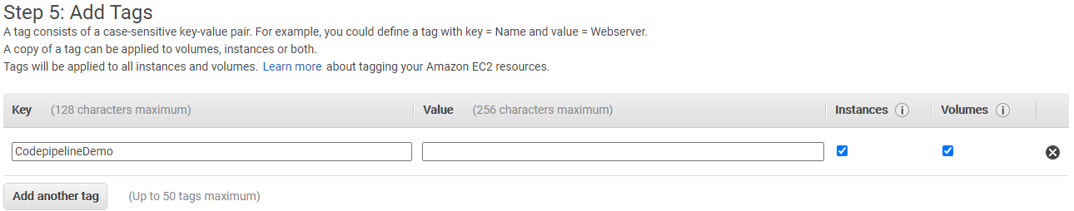

Add rule Add HTTP 80 rule

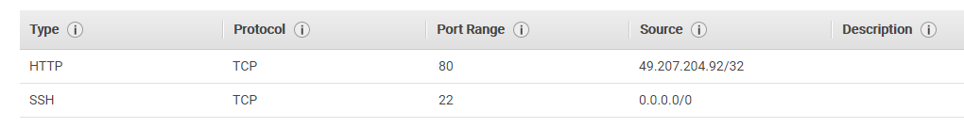

Step 4 Create code deploy service role

Go to IAM Service -> Select the Codedeploy service as below

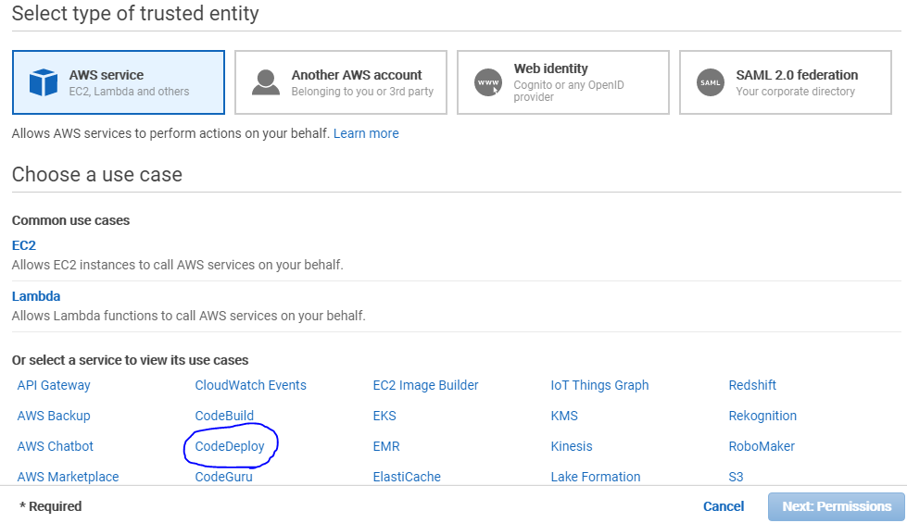

Select the use case as code deploy

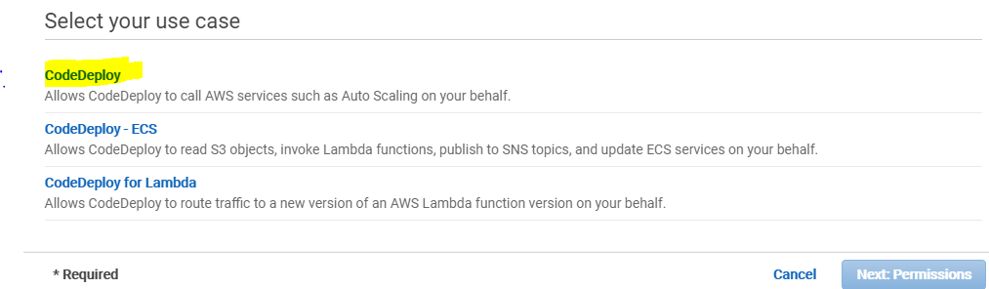

Next click on permission -> It will auto select the role as below

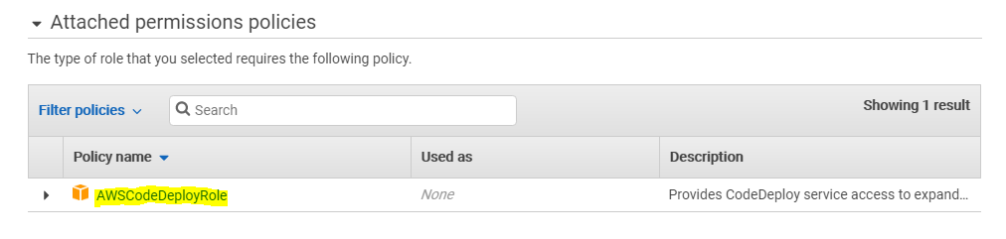
Skip Tag -> Give role name -> create role

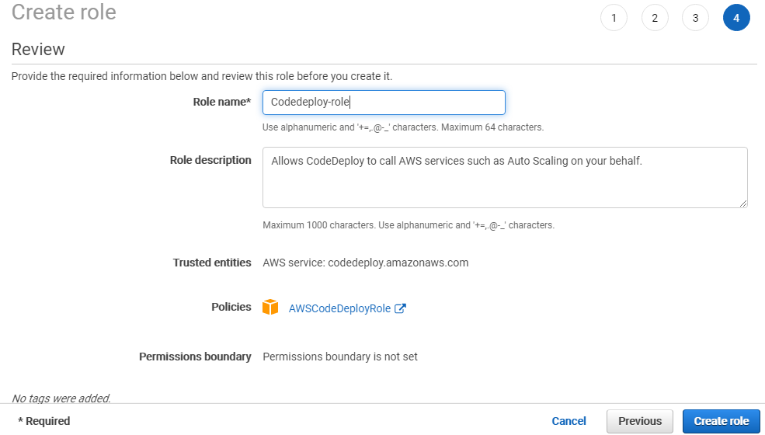

Step 6 Go to codedeploy service -> click on application -> create application

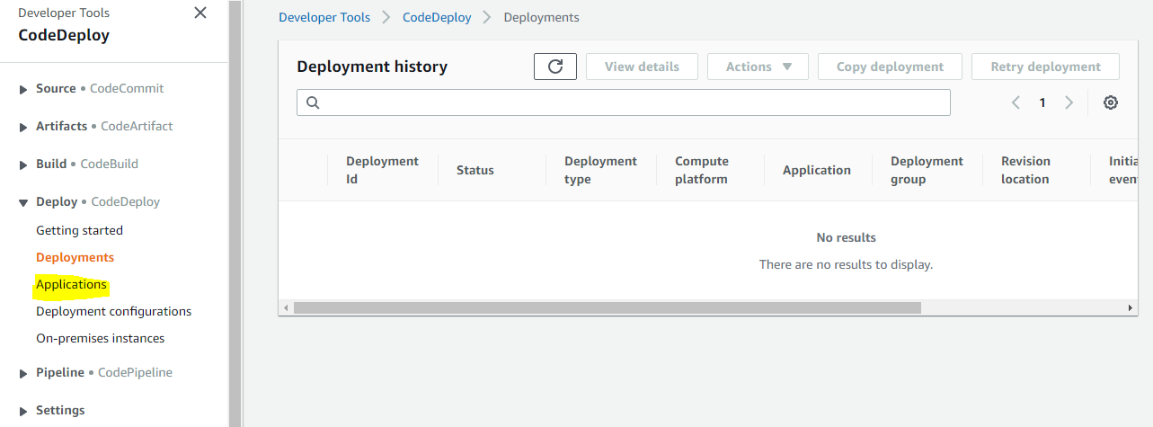

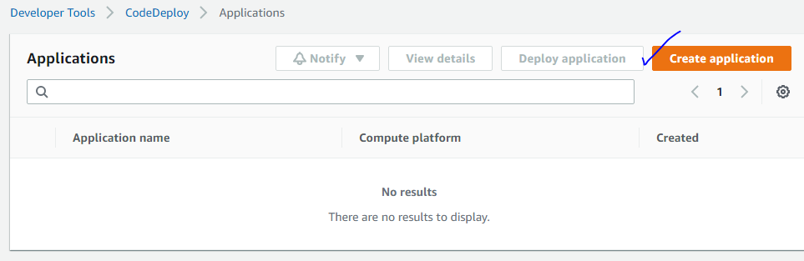
Give application name -> select compute platform as EC2/On-premise

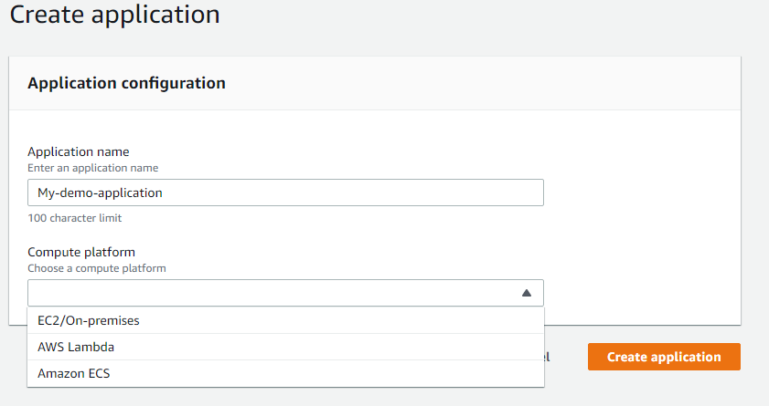

Application is created and now we have to create deployment group

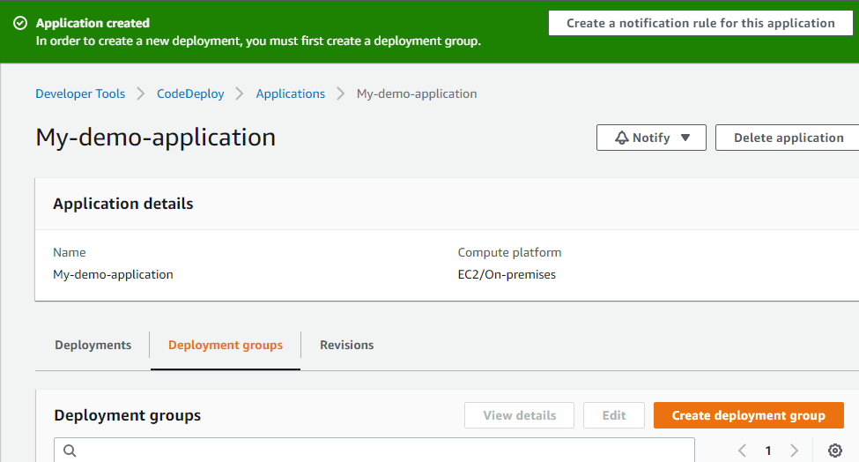

Click on create deployment group -> give name -> select the role as code deploy role which we have created

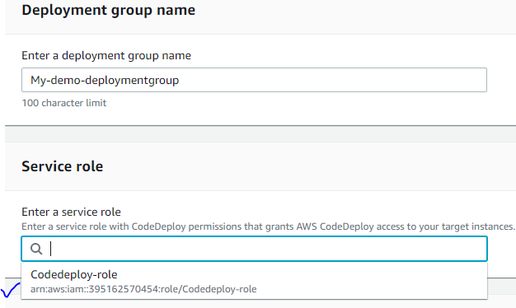

Select deployment type as In-place

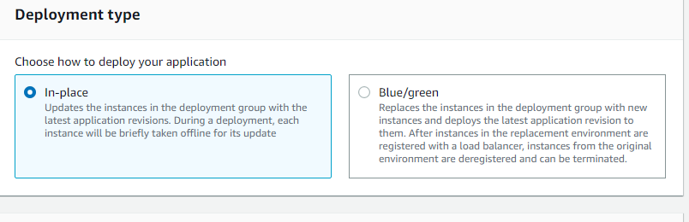

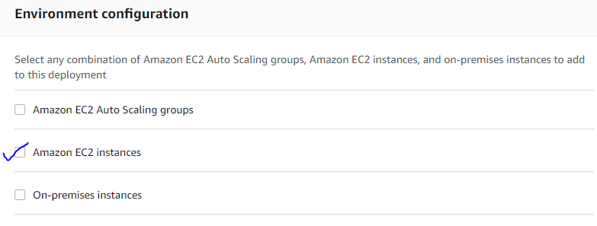
You can install code deploy agent again

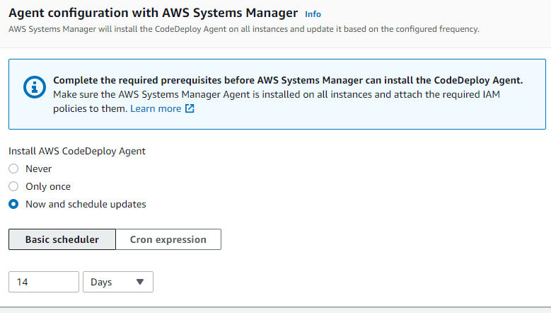

Depending upon the number of running instances you can select your deployment settings

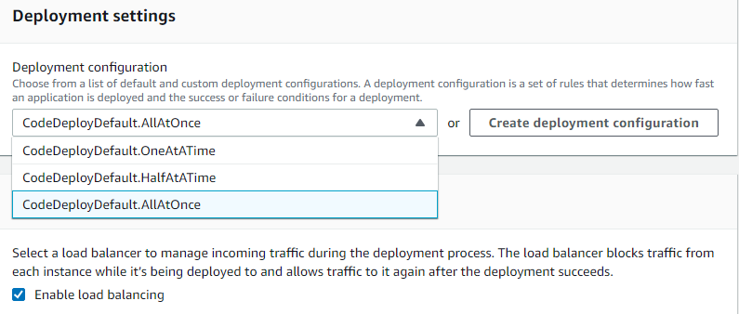

In the advanced section you can add triggers and alarms and then click on create deployment group

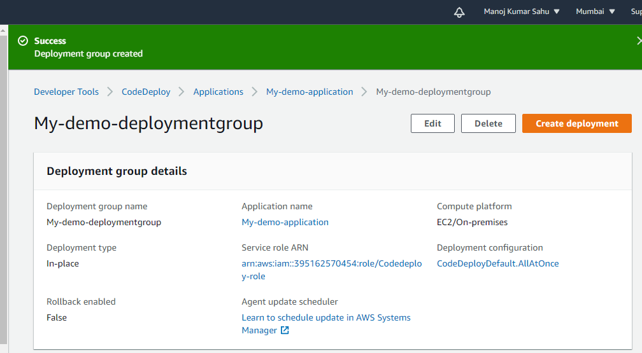
Step 7 Create pipeline. Give pipeline name and service role will be automatically created

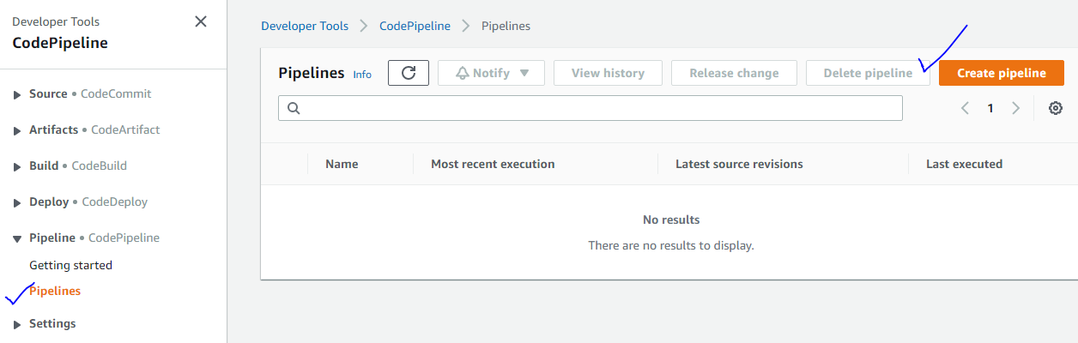
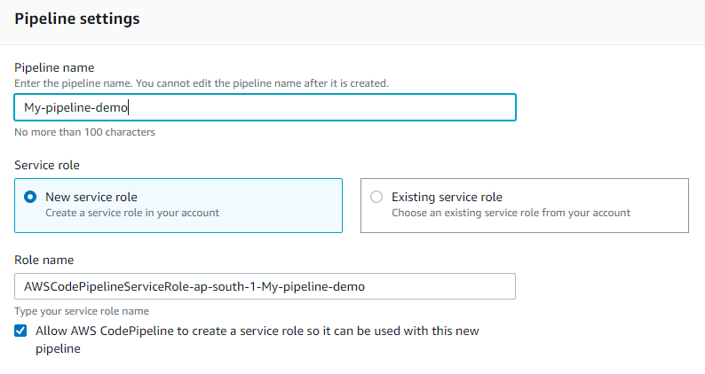
In the advanced section leave the setting as default as below and click Next

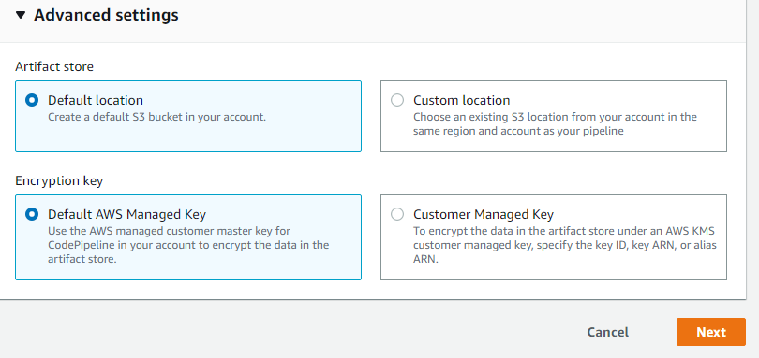
Select Add storage as S3

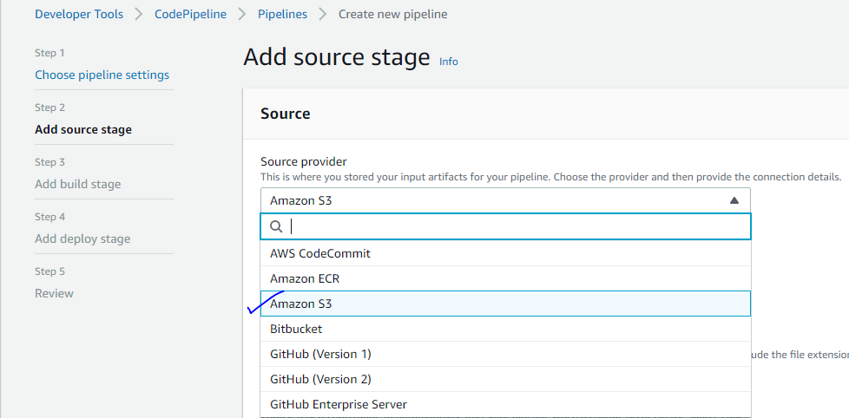

Select bucket and S3 bucket key as same as the application file name
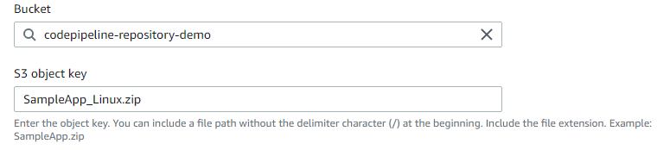
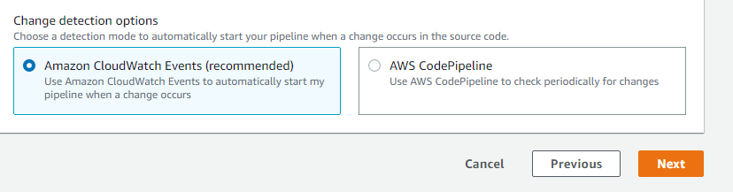
Click Next

Skip the build stage and click next

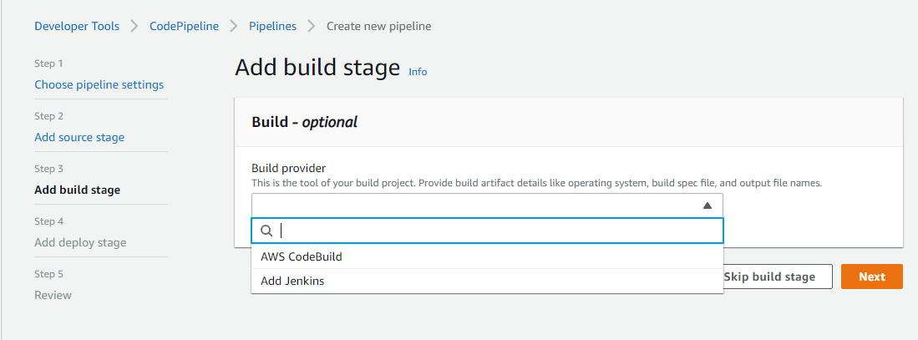

You have to add deploy stage and deploy provide as codedeploy

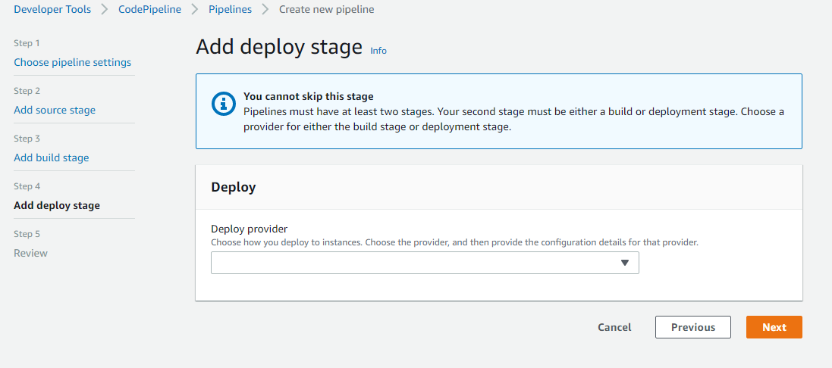

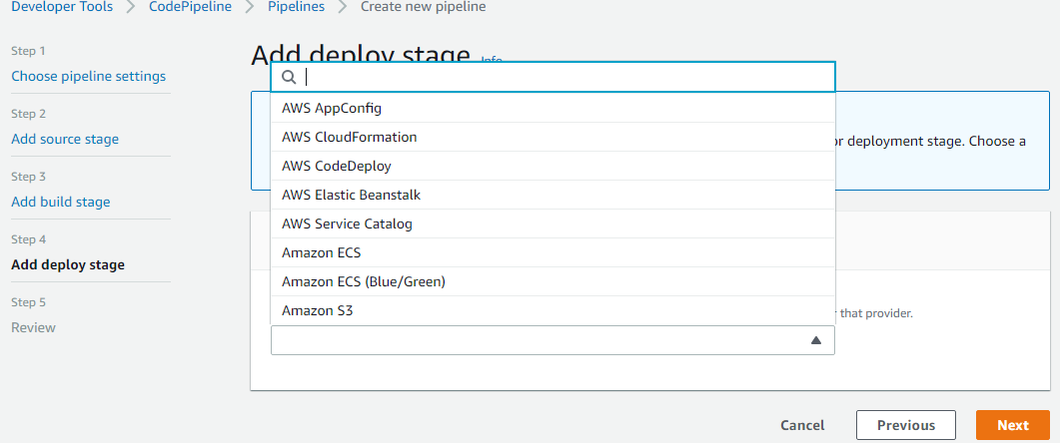

Fill the details of application name and deployment group

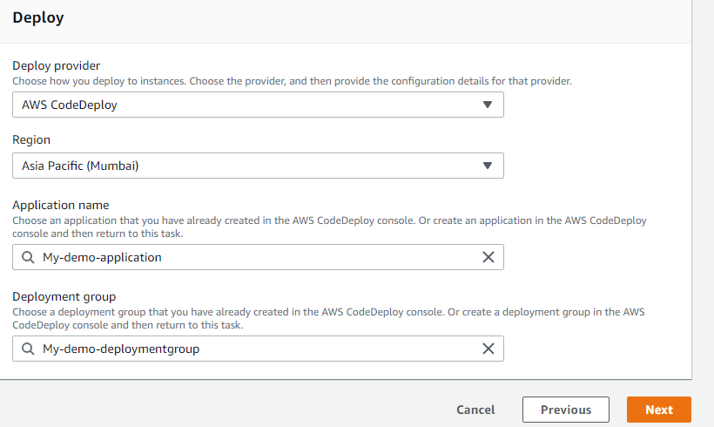
Click Next -> Click Preview -> Create Pipeline

It will take few seconds and automatically start deployment
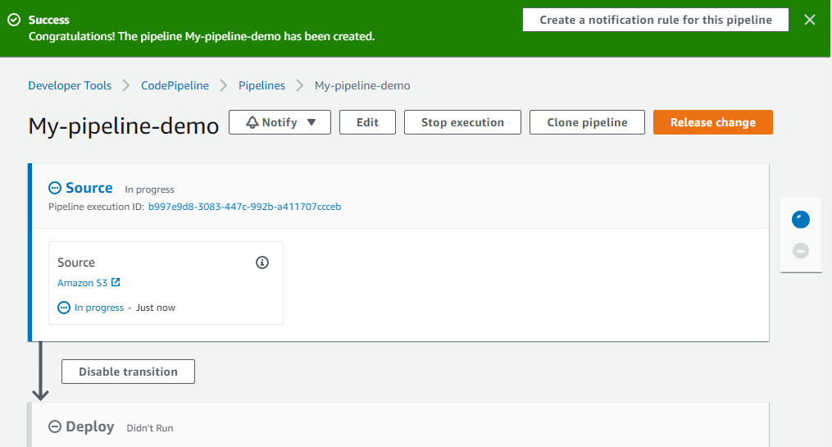

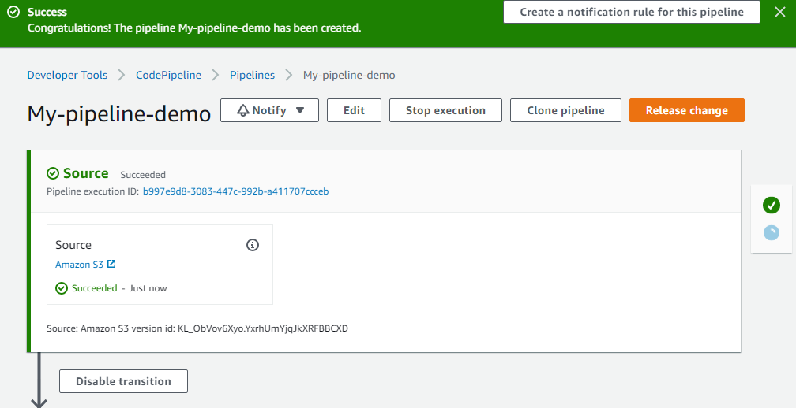

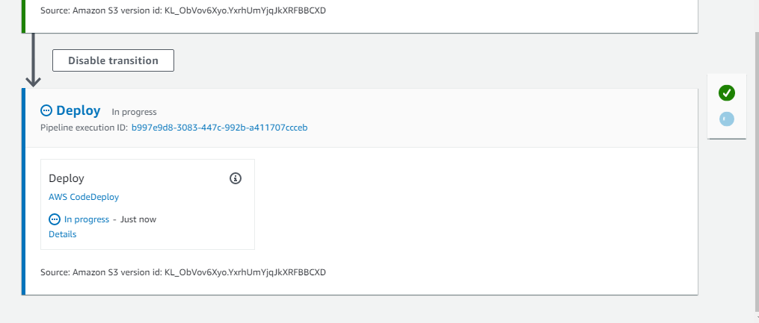

You can see deploy stage progress details clicking on the details

